
Description:


Capacitance level transmitter is used in level sensing applications of variety of Liquids. It’s available for non conductive as well as conductive liquids. It is offered with PTFE sleeve for better insulation & to withstand high temperature.
In conductive tanks the insulated probe acts as one electrode & the tank wall as another electrode, any change in liquid level the dielectric value will change thereby changing the capacitance value proportional to the liquid level. In case of non conductive media applications / non conductive tanks, a reference probe is provided as ground electrode. The output is 4-20mA, 4 wire connection for Isolated supply & 3 wire for non isolated supply.
The tank empty ( 4mA) & full (20mA) calibration is through easy field calibration button in case of 4 wire & 3 wire. Rigid probe is offered for tank depth upto 3 mtr & Flexible probe upto 30 mtr.
Rigid Probe with Grounding tube is suitable for Fuel Level
measurement. It is available with different mounting arrangement to suit customer requirement.
It is widely used for Diesel, Petrol, Ethenol, Solvents, Oils, chemical & pharma applications.

Model: CPLT1200F
Make: Levtron Instruments Pvt. Ltd. Pune

Technical Specifications:
Type: Capacitance Level Transmitter 4 Wire Supply: 24 V DC
Output: 4-20 mA Permissible Load: 500 Ω
Measurement Range : 200MM to 2000MM in Rigid Probe. (Up to 30000 MM in Flexible Probe for other Liquids).
Max Pressure: Up to 5 KG/CM3 Temperature: 25 to 120°C
Enclosure: Dicast Aluminium Flameproof IP 66 Resolution: 0.5 MM
Accuracy: 0.5% of Full Scale.

Process Connection: 1”/ 1-1/2” BSP/NPT/ Flanges(Specify). Cable Entry: ½” or ¾” ET / NPT ( Specify)

Salient Features:
- Compact size with integral electronics
- Pre calibrated. And Easy for Re-calibration on site.
- No moving parts so no wear and tear
- 4-20 mA isolated Output.
- Flameproof IP 66 ingress protection
- LED indicators for status

Mechanical Drawing:

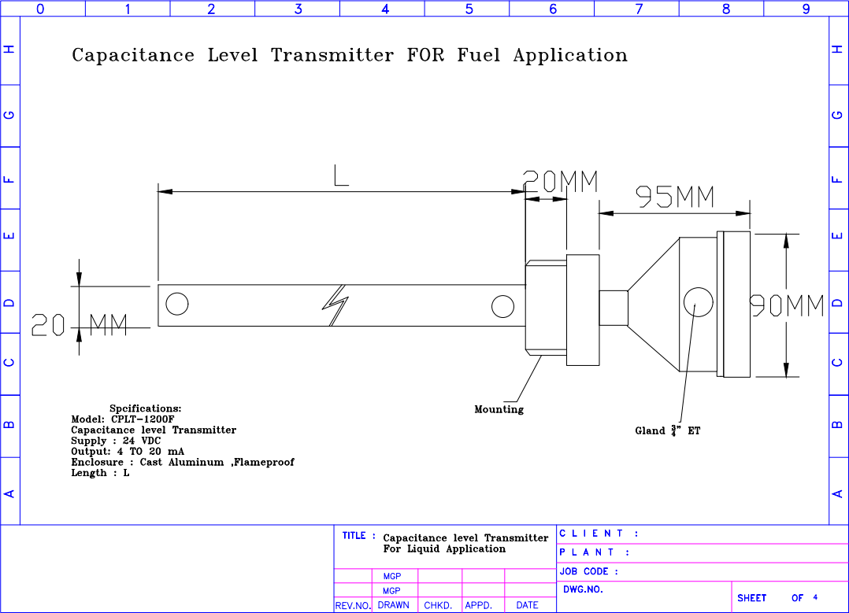

Electrical Connections:
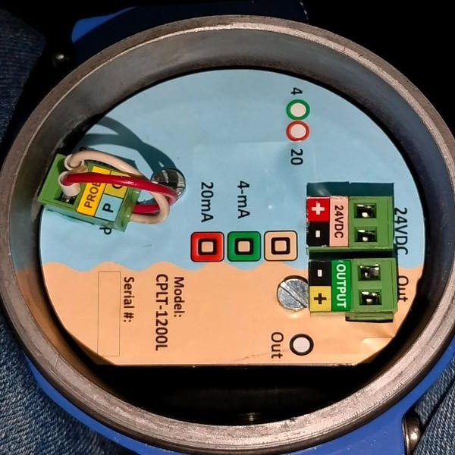
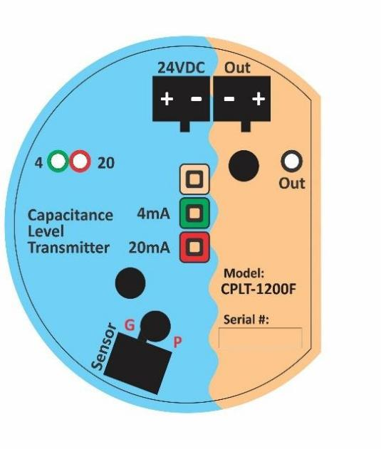

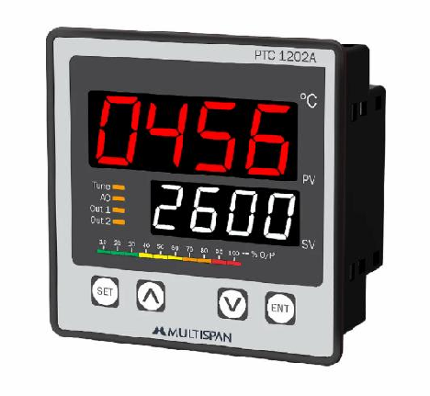
Instrument Supply: 24 V DC Output: 4_20 mA ( 3 wire/ 4 Wire)

Process Indicator Display:

Power supply: 230 V AC 5O Hz / 24 V DC @ 3 VA Max Specify. Out Put: standard SPDT Relay x2 Nos, 4-20 mA Retransmission
For Sensor Supply: 24 V DC 2 250 mA Max.
OPTIONAL Communication Output: Programable RS 485 Modbus protocol. Relay output: 2 x Potential free C/O contacts rated at 6A 230 V AC 50 Hz

Manufactured By:

Levtron Instruments Pvt Ltd. Office No 2, 1st floor, plot no 6,
Pandhari Industrial estate, Shivane. Pune 411023,
Contact: 09579430012 / 9730042725
E-mail: sales@levtron.in Website : www.Levtron.in

